**Name: Merlin Moncy**

**Roll No:21**

**Batch:MCA -B**

**Date:21-04-2022**

**NETWORKING & SYSTEM ADMINISTRATION LAB**

**Experiment No.: 7**

**Aim**

Familarization of linux commands

**Procedure**

1. **read**

The Linux **read** command is used to read the contents of a line into a variable.

Syntax

$read variable_name

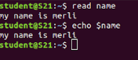

**2. locate**

The locate command and [find](https://www.javatpoint.com/linux-find)command is used to search a file by name. But, the difference between both commands is that locate command is a background process and searches the file in the database whereas, find command searches in the filesystem. The locate command is much faster than find command.

Syntax

$locate filename.txt



**3. locate -i**

It is used to ignore case sensitivity of the specified patterns.

Syntax

$locate -i filename.txt



**4 find**

The find command helps us to find a particular file within a directory. It is used to find the list of files for the various conditions like permission, user ownership, modification, date/time, size, and more.

Syntax

$find filename.txt



**5.grep**

The 'grep' command stands for **"global regular expression print"**. grep command filters the content of a file which makes our search easy.

Syntax

$grep word filename.txt



**6. grep -i**

The 'grep -i' command filters output in a case-insensitive way.

Syntax

$grep -i word filename.txt



**7 grep -v**

The 'grep -v' command displays lines not matching to the specified word.

Syntax

$grep -v word filename.txt



**8. grep -A**

grep -A command is used to display the **line after the result**.

Syntax

$grep -A word file.txt



**9. grep -B**

grep -B command is used to display the **line before the result**.

Syntax

$grep -B word file.txt

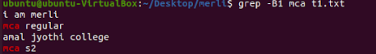

**10.grep -C**

grep -C command is used to display the **line after and line before** the result.

Syntax

$grep -C word file.txt

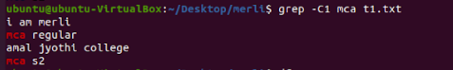

**11. df**

Linux df command is used to display the **disk space used in the file system**. The 'df' stands for **"disk filesystem**." It defines the number of blocks used, the number of blocks available, and the directory where the file system is mounted.

Syntax

$df

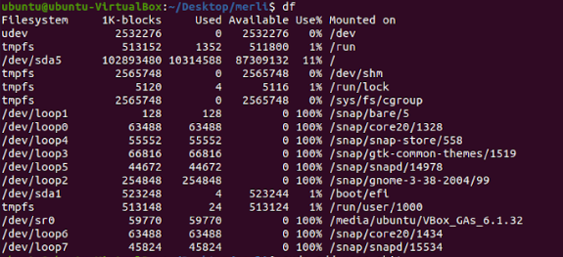

**12. df -m**

it is used to see the report in mega byte

Syntax

$df -m

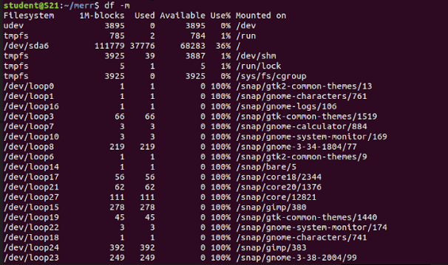

**13. du**

To check how much space a file or directory take.

Syntax

$du



**14.wc**

Linux wc command helps in counting the lines, words, and characters in a file. It displays the number of lines, number of characters, and the number of words in a file. Mostly, it is used with pipes for counting operation.

Syntax

$wc filename.txt



**-l, --lines:** It is used to print the newline counts.

**-w, --words:** It is used to print the word counts.

**-c, --bytes:** It is used to print the byte counts.

**-m, --chars:** It is used to print the character counts.

